TIC-TAC-TOE GAME

AIM: To implement a python program for Tic-Tac-Toe game.

OBJECTIVES:
- To understand the use of lists in Python.
- To implement a simple game logic using conditions and loops.
- To check winning combinations in Tic-Tac-Toe.
- To identify a winner or draw.
- To improve basic problem-solving and programming skills.
ALGORITHM:
- Create a 3×3 board with empty spaces.
- Display the board to the players.
- Player 1 uses X and Player 2 uses O.
- Ask the current player to enter a position from 1 to 9.
- Place the player's symbol in the selected position.
- Check all possible winning combinations.
- If a player gets three matching symbols, declare them the winner.
- If all positions are filled without a winner, declare the game a draw.
- Otherwise, change the player and continue the game.
SYSTEM-ARCHITECTURE:
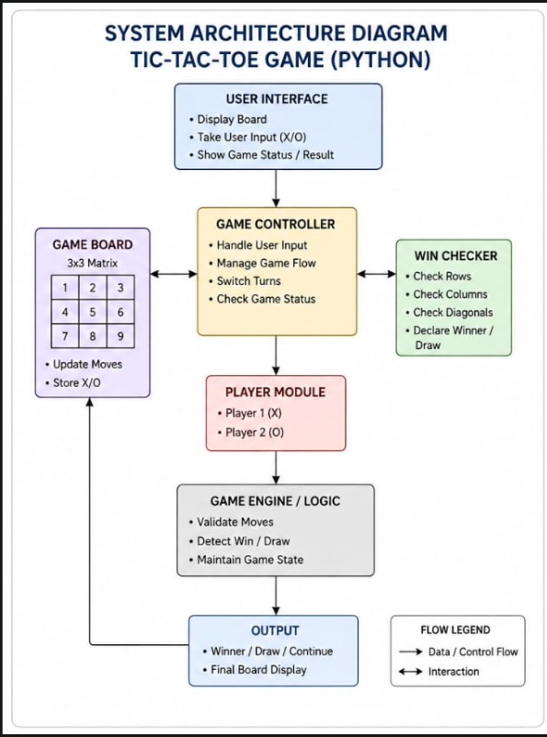

PROGRAM:
board = [" "] * 9

def show():
print(board[0], "|", board[1], "|", board[2])
print("--+---+--")
print(board[3], "|", board[4], "|", board[5])
print("--+---+--")
print(board[6], "|", board[7], "|", board[8])

def win(p):
ways = [(0,1,2), (3,4,5), (6,7,8),
(0,3,6), (1,4,7), (2,5,8),
(0,4,8), (2,4,6)]
return any(board[a] == board[b] == board[c] == p
for a,b,c in ways)

player = "X"

for turn in range(9):
show()
pos = int(input("Player " + player + ", enter position (1-9): ")) - 1

if board[pos] == " ":
board[pos] = player

if win(player):
show()
print("Player", player, "wins!")
break

player = "O" if player == "X" else "X"
else:
print("Position already taken!")
else:
show()
print("Game Draw!")

OUTPUT:
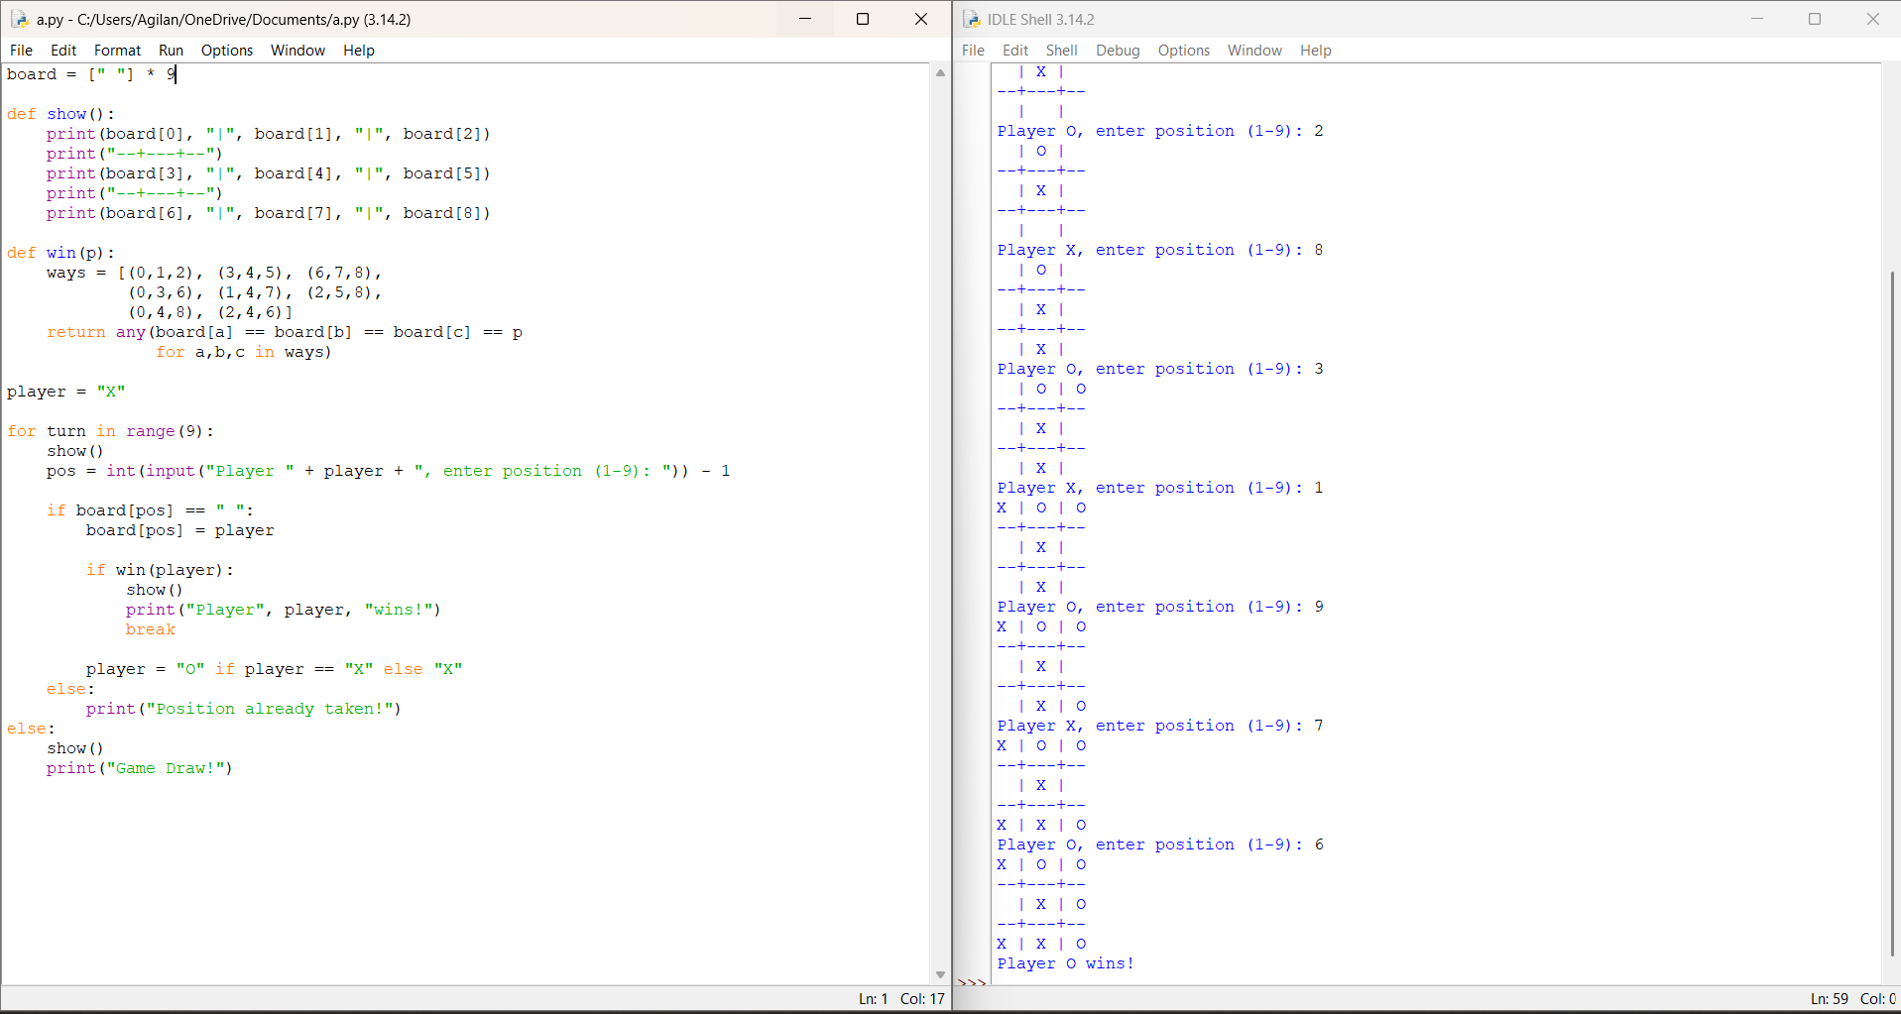

RESULT: Thus the Tic-Tac Toe game is implemented successfully using python language.

